Pocket-X
INFO LETTER
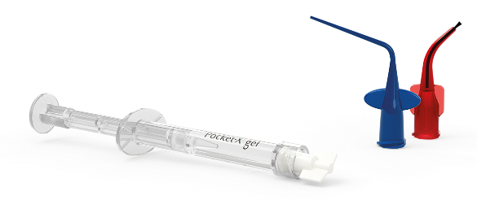
Pocket-X® Gel - Product Info

- What is Pocket-X® Gel?
- A prefilled syringe for periodontal pockets
- Indications: Improve the healing of the gingiva and inhibit bacterial re-colonization in the periodontal pocket
- Contents:
  - Hyaluronic acid: Provides elasticity
  - Poloxamer 407: Thermosensitive filler component
  - Octenidine HCl: Antimicrobial preservative
  - Phenoxyethanol: Part of preservative system
- Pocket-X® Gel is a liquid at room temperature that transforms into a viscous gel within seconds after application. Thus, Pocket-X® Gel fills even the deepest periodontal pockets and does not leak out when inserted.

- When can you use Pocket-X® Gel?
- As an adjunct to Scaling and Root Planning (SRP) in initial periodontal therapy and during supportive periodontal care (maintenance phase/recall)

- What makes Pocket-X® Gel so unique?
- Novel in-situ liquid-to-gel vehicle unlike anything else on the market
- Physical mode of action prevents bacterial recolonization and improves healing of the gingiva
- Patented innovative formulation, unique blend of ingredients
- Evidence for clinical efficacy
- Class IIa medical device, application possible by all oral healthcare professionals

- Handling and patient communication
- Use after the root surface debridement/scaling treatment
- Pocket-X® Gel is available in packs of 3 syringes, each containing 1.0 ml
- One syringe is sufficient for several periodontal pockets in one patient (usually 5-10 pockets)
- Do not freeze or refrigerate, store at 15–25 °C (room temperature)
- Use one syringe only for one patient, do not store and re-use the same syringe
- A longer blue tip as well as a shorter and wider red tip (with a brush) are included with each syringe
- Patient recommendations (see also IFU):
  - First 2 hours – no eating, no gargling, no rinsing
  - First 4 hours – no hot drinks
  - First 2 days – brush the treated sites gently

